10.33: a) 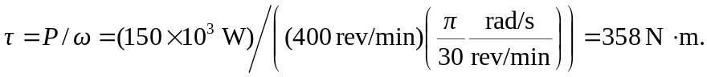
b) If the tension in the rope is

c) Assuming ideal efficiency, the rate at which the weight gains potential energy is the power output of the motor, or Equivalently, 